Dadirri Devotion | 2021 [Marilyn Wall]

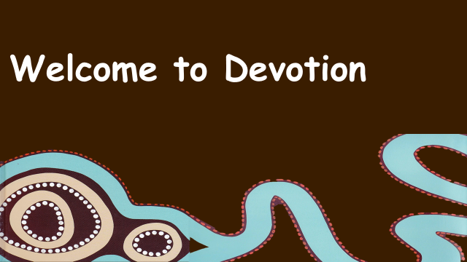 | Computer Audio On  Camera On  PPT slide on  Check red border around slide to ensure it is visible to audience
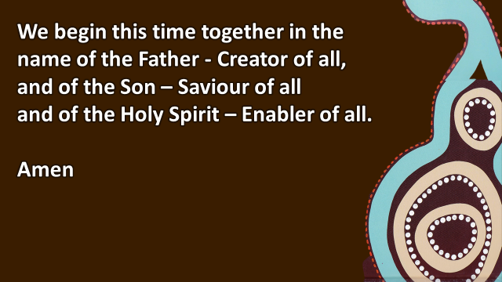 | We begin this time together  in the name of the Father - Creator of all,  and of the Son – Saviour of all  and of the Holy Spirit – Enabler of all.  Amen
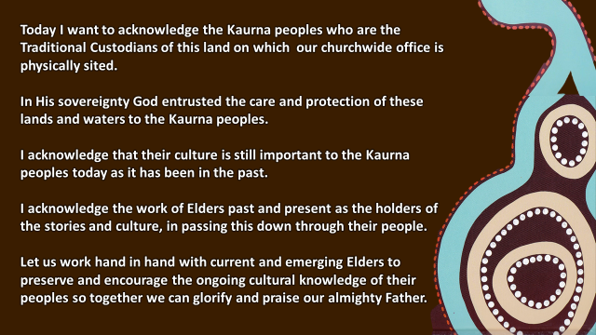 | Acknowledgement of Country  I acknowledge the Traditional (include name in known eg Kaurna) peoples who are the Traditional Custodians of this land on which our churchwide office is physically sited.  In His sovereignty, God entrusted the care and protection of these lands and waters to the Traditional (include name in known eg Kaurna) peoples.  I acknowledge their culture is still important to the Kaurna peoples today as it has been in the past.  I acknowledge the work of Elders past and present as the holders of the stories and culture, in passing this down through their people.  Let us work hand in hand with current and emerging Elders to preserve and encourage the ongoing cultural knowledge of their peoples so together we can glorify and praise our almighty Father
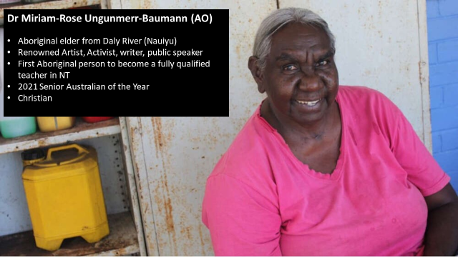 | Perhaps you know this face - Dr Miriam-Rose Ungunmerr-Baumann (AO)  Named as Senior Australian of the Year in the 2021 Australia Day Awards this year – you may have seen her in some of the promotion leading up to Australia Day ….. perhaps you stopped for a moment to hear her response to being awarded this honour.  We have a small glimpse into the person of Dr Ungunmerr-Baumann (on the slide)  - Aboriginal Elder from Daly River (Nauiyu), NT  - Renowned artist, activist, writer, public speaker  - First Aboriginal person to become a fully qualified teacher in NT … spent the majority of her life as an educator with a passion for the education of Aboriginal children  - 2021 Senior Australian of the Year  - Christian (all the above is ‘couched’ in her identity as a Christian)
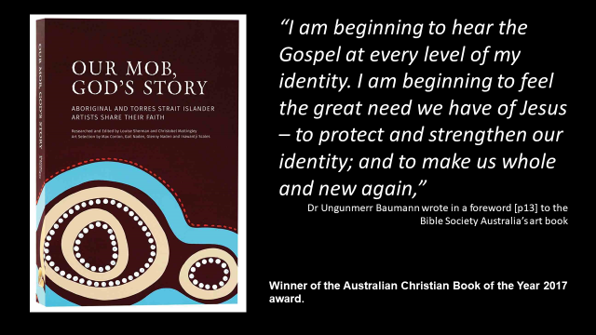 | Many will be familiar with this publication – winner of the Aus Christian Book of the year 2017  Dr Ungunmerr-Baumann has the distinguished honour of having written the Foreword for this book, (Pg 13) – it is recommended reading.  As she publically declares her identity lies in Jesus Christ as much as it it does in her Aboriginality.
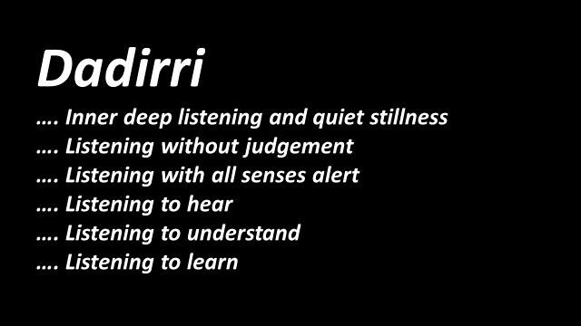 | I’d like to share with you one of the spiritual concepts that I have come across time and time again when exploring Aboriginal culture.  And that is the cultural spirit Dadirri.  It is probably called something different in different language groups, but it never-the-less appears to exist in the culture of Aboriginal language groups across Australia.  I sense also that ‘Dadirri’ exists in many cultures across the world … it just isn’t so well known in the ‘westernised culture’  Dadirri is the practice of inner deep listening and quiet stillness  … not just as we might presume, in listening to people …. But firstly to land and nature, the seasons and expressions of time and all that surrounds us.  Dadirri is  - Listening without judgment  - Listening with all sense alert  - Listening to hear  - Listening to understand  - Listening to learn  Dr Miriam explains …. Aboriginal people passed on stories orally because they knew no writing. Listening intently, deeply to the story-teller was vital to reproduce the story accurately to the next generation of story-tellers.  Deep listening describes the processes of deep and respectful listening to build community—a way of encouraging people to explore and learn from the ancient heritage of Aboriginal culture, knowledge and understanding [1].  Source: Deep listening (dadirri) - Creative Spirits, retrieved from https://www.creativespirits.info/aboriginalculture/education/deep-listening-dadirriI  It is through Dadirri, that the Elders, the holders of the stories and culture have been able to pass this knowledge down through the many generations – I guess in our way of thinking it was their form of an educational system but it was and is so much more.  "In our Aboriginal way, we learnt to listen from our earliest days. We could not live good and useful lives unless we listened. This was the normal way for us to learn – not by asking questions. We learnt by watching and listening, waiting and then acting."  Source: Deep listening (dadirri) - Creative Spirits, retrieved from https://www.creativespirits.info/aboriginalculture/education/deep-listening-dadirri
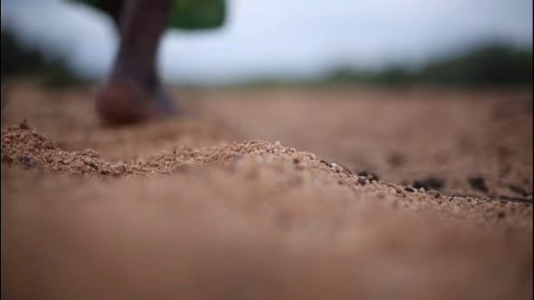 | Share a video explanation by Dr Baumann herself.  Click on the video start arrow on the bottom of the slide  https://youtu.be/tow2tR_ezL8
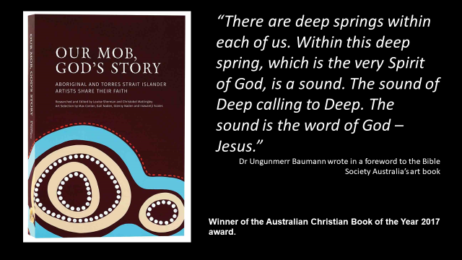 | Dr Ungunmerr-Baumann explored this concept in her foreword to Our Mob, God’s Story, saying: “There are deep springs within each of us. Within this deep spring, which is the very Spirit of God, is a sound. The sound of Deep calling to Deep. The sound is the word of God – Jesus.”  Dr Miriam continues as she explains how her Aboriginality and Christianity have been key in informing her own sense of timing and purpose throughout her life and work:  “Our time is short. People will come after us, and they will tell the stories that we have told them, again. In Aboriginal society that is how we survive – telling the stories, sharing the knowledge, showing the places to gather food and water, passing on the ceremonies. As we grow older, we continue to pass on the stories to our children in our communities. Through our words and actions we tell them about our ways. We help them to grow strong to make their judgements.”  Dr Ungunmerr-Baumann draws a parallel in this to the Scriptures ….  “The writers of the Bible also used stories to share their knowledge.  Without the stories the Apostles passed on, we wouldn’t have heard about Jesus’ life.  Like the Apostle, we are called to pass on the Good News of Jesus. It is a repeating story – about life, growth and telling the story to others.  And we believe it is always in God’s time …  “Our Aboriginal culture has taught us to be still and wait … We wait on God, too. His time is the right time. We wait for him to make his Word clear to us. We don’t worry. We know that in time and in the spirit of dadirri, that with deep listening and quiet stillness, His way will be clear.”
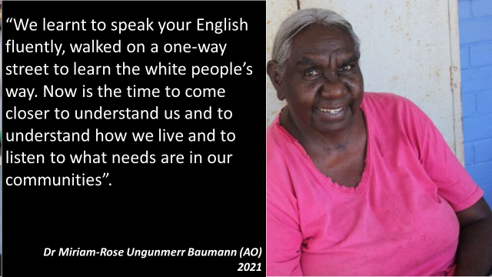 | In accepting the 2021 Senior Australian of the Year Award – her third time being nominated – this 70 plus year-old challenged non-Indigenous people saying ….. “We learnt to speak your English fluently, we learnt to walked on a one-way street to learn the white people’s way. (Perhaps) Now is the time to come closer to understand us and to understand how we live and to listen to what needs are in our communities.”
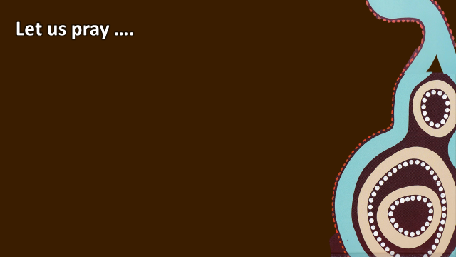 | Let us Pray ..  Almighty Father  We praise and thank you for all that you have given us – especially the gift of the eternal life won for us through the death and resurrection of your Son.  We seek to recognise and tap into the Dadirri, that deep spring within each of us – calling to us to know you more deeply, hear you more clearly, responding in ways that reflects your immense love for us, to others.  Thank you for the opportunities we have to learn about you from others and their spiritual connection to You and Your Word.  Help us to be respectful of, and find further ways we can walk together and learn from each other.  In Jesus Name we pray. Amen
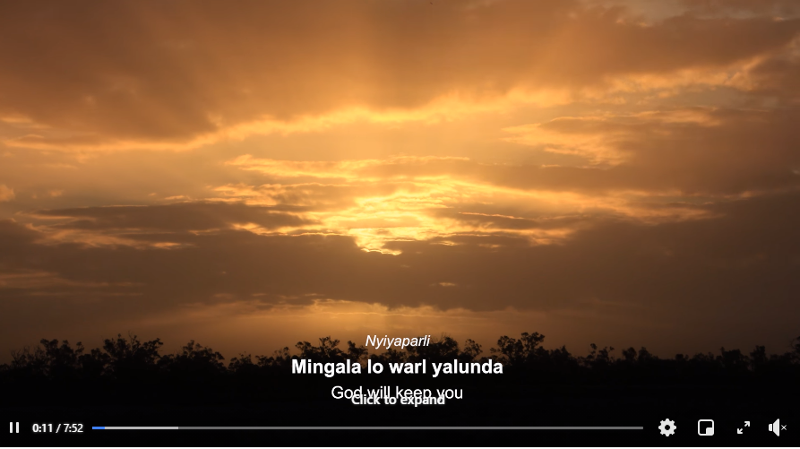 | In finishing … I’d like to leave you with this snippet of a chorus of Indigenous voices representing a range of churches. This reflects many differing cultures as they present their version of a united Australian Indigenous Blessing … You might find it useful background to some deep listening of your own.  https://www.facebook.com/watch/?v=221592362922841

