‘Many Eyes’ Artwork
Inspiration of the LCA’s Reflect Reconciliation Action Plan (RAP)
Scripted powerpoint presentation
Note to presenter: currently there is no animation within each slide, the image and text appear together ….. an alternative presentation could be to first bring up the image and animate the text to follow or combination as per the presenter’s preference. Having a pointer will help people to focus on specific aspects throughout the presentation

1 | 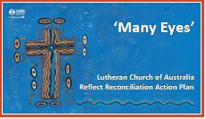 | Welcome | Prayer | Introduction  Context  - Aboriginal/Torres Strait Lutheran communities continue today across Australia. It is estimated that there are between 6,000 – 7,000 Aboriginal/Torres Strait Islanders who identify as Lutheran predominantly in the following areas:  - SA: Port Lincoln, Ceduna, Koonibba, Yalata, Oak Valley, Ferryden Park  - NT: Central Australia …. 40 (approx) communities Alice Springs, Hermannsburg, and surrounding communities  - QLD: Hope Vale, Wujal Wujal, Coen  - Scattered groups within the rural and more urban areas of towns and cities across Australia (we should never assume that we do not have Aboriginal or Torres Strait Islander people worshipping with us in our ministry spaces)  - LCA has more than150 years of history of ministry and engagement with First Nations / Aboriginal and Torres Strait Islander peoples  - Great stories exist of Aboriginal and non-Aboriginal peoples working together, side by side, together, to share the Christian gospel and growing as God’s people across Australia.  - Outside of these Lutheran Aboriginal communities, many of these great stories are not well known amongst the wider Lutheran church, with even less understood or appreciated of the differing cultures of First Nations peoples and what is important to them and their faith journeys as a valued part of the Lutheran Church.  - At the 2018 LCA General Convention of Synod – our church said we can do better – and voted yes to developing a Reconciliation Action Plan (RAP).  - The first step in this process was to develop and prepare a Reflect RAP ….. Where as a church we would first reflect on our past and existing relationships with First Nations peoples.  - Amongst a range of consultative decisions about the development of the RAP, an artwork was developed to inspire the thinking and appreciation for the task ahead us.  - As you can see on the screen – the artwork is of the Cross entitled ‘Many Eyes’ …. it has become this inspiration.
2 | 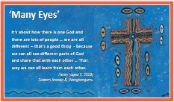 | - This artwork (Many Eyes) is the handiwork of a young Aboriginal boy, Henry.  - Henry’s family heritage extends to Eastern Aranda (North East of Alice Springs) and Wangkangurru (Simpson Desert SA)  - Henry was just 9 years of age in 2018, when he created this artwork.  - As part of a Reconciliation Week exercise in his school (a Lutheran school) Henry along with his class was asked what they understood by reconciliation.  - …. Listen/Read what Henry has to say about his painting.  It’s about how there is one God and there are lots of people … we are all different – that’s a good thing - because we can all see different parts of God and share that with each other … That way we can all learn from each other.  - This from the mouth of a 9 year old!
3 | 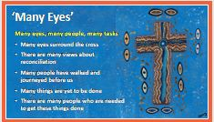 | Others have looked at this artwork and the following are their thoughts of the things they drew from Henry’s painting  - Many eyes, Many people, Many tasks  - Firstly, focus on those images around the cross – some we can easily recognise as eyes, others are smaller – there are lots of them (79 pairs + 147 ‘eyeballs bordering the cross!!!!)  - These eyes represent that there are many thoughts, ideas and views about reconciliation …. this is okay and these differing views do not have to be problematic  - The many eyes represent the many people who have been on this journey – some for many years  - At present the reconciliation journey has not reached its destination – these many eyes represent the many things yet to be done  - And there are many people who are needed to get these things done  - Perhaps you can see something further
4 | 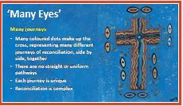 | - Many Journeys  This striking use of the cross highlights that God makes a journey of reconciliation in the journey of Jesus Christ on earth, who goes to give his life for all on the Good Friday cross.  As a result, all people are reconciled with God because of Christ’s love and sacrifice. Isn’t that the gospel?  Our response is to engage in our own journey of reconciliation with each other.  Now focus on the many coloured dots making up the cross …. what do you notice?  Some who have been previously asked this question have suggested  - Many different journeys of reconciliation have, or are yet to be travelled  - True reconciliation journeys are travelled together, side by side, Aboriginal and non-Aboriginal people together as equals as God created us  - Notice how the rows of dots are wavy and crooked – demonstrating that reconciliation journeys are rarely straight forward, we can expect bumps, potholes and barriers along the way– these bumps and diversions enriches the experiences, relationships and the outcomes of the journey  - No journey of reconciliation is the same – each is different because each of us are unique – that is why sharing the journey with others is such an enriching experience  - For genuine and sustained reconciliation we must be prepared to seek the Holy Spirit, to help us to embrace, effort and hard work over time ….. reconciliation is complex
5 | 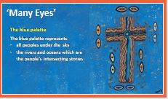 | - The blue palette  Notice the colour of the background on which the cross is laying.  It is blue ….  - Some suggest that this represents all the peoples under sky for whom God sent his son Jesus to die, so that all peoples under the sky could be reconciled back to God – he paid the price. Jesus has walked that journey of reconciliation for you and for me and for all peoples …. So that we can work together to be reconciled with each other  - Some have suggested that ‘blue’ represents the rivers and the oceans …. all water, one fresh and the other salt …. two distinct identities – but never the less each eventually connecting with each other …. Could this be the intersecting stories of Aboriginal and non-Aboriginal people … rich stories which we share, and from which we learn to respect and value each other
6 | 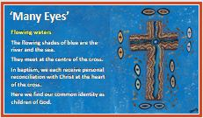 | - Flowing waters  Now focus on the darker blue and lighter blue colours up and across the centre of the cross  - We’ve just talked about the blue representing the river and the sea  - Notice how in their separate flows they meet …. at the centre of the cross and flow in those circles  - Water is one of the elements of baptism …. it is in baptism that we receive our personal reconciliation with God through the cross of Christ … the gift of the cross
7 | 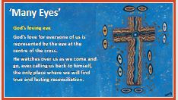 | - God’s loving eye  Let’s now focus on the centre of the cross … particularly that white dot, surrounded by those circles of blue – the river and the sea!  - Some have seen that this represents God’s love for us all … it is central to the cross  - God’s loving eye watching over each one of us as we make our choices in life …. ever calling us back to himself … and the only place where we find true and lasting reconciliation.
8 | 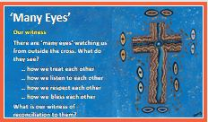 | - Our witness  Let us return for a moment to those ‘eyes’ surrounding the cross  - Yes there are ’many eyes’ observing us …. you and I who identify as children of God …. we are being watched from outside the ‘church’  - What do those ‘outside’ eyes see?  - What is our witness to others of our faith in the  …. way we treat and care for each other?  …. how we listen to each other?  …. how we respect and speak to, and about, each other?  …. how we bless and encourage each other?  - What is our witness of reconciliation to them?
9 | 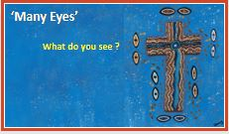 | - What do you see ?  - Perhaps you can draw other things from this story about the importance of reconciliation ….  - You are encouraged to continue to think about this and reflect on your own personal journey of reconciliation  - Maybe you might be led to action that enriches your current journey ….. or maybe be inspired to commence it today … maybe walk and share this journey with family and friends  - It doesn’t have to be this grand ‘showy’ action … remember every journey starts with the first step  - Reconciliation is always journeyed on a road under construction that is often in need of repairs …. avoid taking short-cuts
10 | 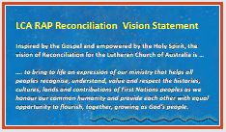 | LCA RAP Reconciliation Vision Statement  Opportunity to reflect on the messages within.  Final prayer

